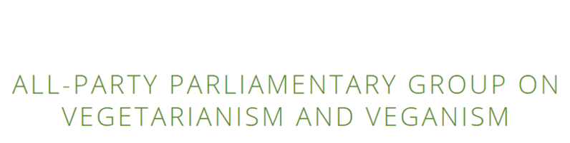

**Planting value in the food system**

15 July 2021 via Zoom video-conferencing

*(Please note this a paraphrased summary of the speakers’ contributions and not a verbatim account.)*

Christina Rees MP, Chair of the APPG on Vegetarianism and Veganism opened the meeting and introduced the speakers.

**Louise Davies, CEO of The Vegan Society**

* Louise discussed the UK’s National Food Strategy Part Two that has launched today and relates well to the findings in The Vegan Society’s report ‘Planting value in the food system’.
* The Vegan Society is pleased to hear the recommendation in the National Food Strategy Part Two to reduce meat.
* ‘Planting value in the food system’ was inspired because it is important to many aspects of our lives including environmental impacts and health concerns.

**Dr Alex Lockwood, The University of Sunderland**

* Alex discussed the report in more depth, including how it proves that The Vegan Society should have a seat at the table in food system discussions in the UK.
* The report has five key elements.
* There is a need for a Food Sustainability Bill and a Well-Being of Future Generations Bill.
* The above legislation should focus on reduction targets for animal product intake and a National Food Sustainability Council to oversee this.

**Alexandra Clark, Advisor at Veg Capital**

* This discussion is happening at the right time and farmers are at the centre of this.
* Promoting more plant-based alternative proteins could create jobs and grow countryside communities.
* There is a need for implementing meat and animal protein VAT.
* There is a need for a plant-based agricultural system, giving farmers support in funding a transition into a new market.

**Dr Helen Harwatt, Senior Research Fellow in Energy, Environment and Resources Programme at Chatham House**

* When considering climate and ecosystems, it needs to be approached from a land assessment perspective.
* Some land may be used for biodiversity or as an ecosystem, but it’s important to remember that farmland will be impacted by climate change.
* Food production should be considered from a land management strategy where ecosystem restoration needs to be considered heavily.
* This vision from the report isn’t exclusive to vegans or vegetarians, it is what is needed for a sustainable future and a food system that works for everyone.
* There need to be biodiverse ecosystems to help the climate crisis because they have multiple benefits.
* Global shifts to vegan diets could remove two-thirds of carbon needed to align with the half needed to be removed by 2050.

**Questions/comments from Parliamentarians:**

* *Christina Rees MP: How do we change this lifestyle? Smokers have changed when having the information available to them. How would this new sustainability bill be enforced? There needs to be government support for this bill because opposition alone couldn’t make it happen. With Brexit, I am concerned about food quality and other nations being moved out and not devolved. The pandemic may encourage farmers to try new things, such as oat milk. Wales has its own climate change department. Climate change goes through every department and all Whitehall departments.* 
  + Alexandra Clark: The research was to create a vision and framed in a way that feels politically possible. The cap was designed with food but not animals in mind. A farmer who changed his farm into a winery found that it was more profitable for him. We need to have the funding, networking, and support for farmers to make these changes.
  + Dr Helen Harwatt: There must be biodiversity and looking for restoration instead of a monoculture of trees.

**Audience questions/comments:**

* *Is there a push to have vegan food and milk in school?*
  + Louise Davies: The Vegan Society’s campaign ‘Catering for Everyone’ encourages all school meals to provide vegan options. The Vegan Society has a ‘rights expert’ who can help with anyone having issues on an individual basis. The National Food Strategy does say schools should accommodate fewer animal products if the government does take on board the food strategy.
* *Would it be better to have a future generation bill first since it exists in Wales already?*
  + Dr Alex Lockwood: The food sustainability came first because we want for the emphasis to be on this point.
* *Are you suggesting that meat has VAT?*
  + Meat is 0% VAT instead of being exempt from VAT currently. Most food has 0% VAT, but other food seen to be less healthy, such as sugary or salty snacks, has a standard rate of 20% VAT.
* *What is the place of zoonotic risks when considering this policy?*
  + Louise Davies: The Vegan Society finds it very difficult to do this because moving towards plant-based farming alone is very difficult. Getting the target to be reduction vs. elimination. It is a tricky question and difficult to give a definitive answer.

**About the APPG on Vegetarianism and Veganism**

The All-Party Parliamentary Group on Vegetarianism and Veganism (VegAPPG) was formed in December 2016. The VegAPPG is chaired by Christina Rees MP and brings together MPs, Peers, and third sector organisations from across the political spectrum to debate, discuss, and campaign on the key issues that vegetarians and vegans face.